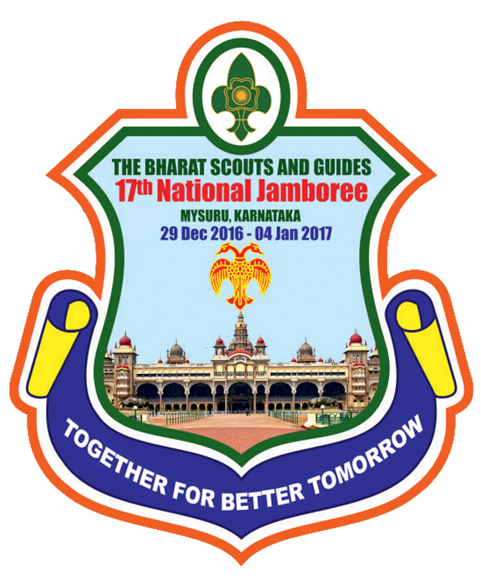THE BHARAT SCOUTS AND GUIDES
NATIONAL HEADQUARTERS
LAKSHMI MAZUMDAR BHAWAN. 16 M.G. MARG, I.P. ESTATE, NEW DELHI 110002
APPLICATION FOR Jamboree service team

17th National Jamboree from 29th Dec, 2016 to 4th Jan, 2017 at Mysuru, Karnataka
Affix photo in Uniform
Name of the State
Name of the Rover/Ranger
(In block letter)
Date of Birth: (Birth Certificate should be attached)
Name of the Group
Address of the Group
(With Pin Code)
Educational Qualification
Scout/ Guide Qualification
Service Experience:
(if you have rendered service as Service Rover/ Ranger)
Mobile No: (if any)
Email Id: (if any)
About you in brief:

_____________________________ _______________________
Signature of Rover/Ranger Leader Signature of Rover/ Ranger
Date: Date:
Place Place:

Recommended the name of Shri/ Smt. /Ku.
Rover/ Ranger of District to work as Jamboree Service Team in 17thNational Jamboree from 29thDec, 2016 to 04thJan, 2017 at Mysuru, Karnataka.

_____________________________ _ ______________________
Signature of State Secretary with Official seal Signature of the SOC (S/G) with Official Seal
Date: Date:
Place Place:

